CPP Lecture Assignment 4:
/*1:Write a program to create student class with data members rollno, marks1,mark2,mark3.Accept data (acceptInfo()) and display using display member function.Also display total,percentage and grade.*/
#include<iostream>
using namespace std;
class Student{
private:
int rollno, marks1, marks2, marks3;
int total;
double percentage;
char grade;
public:
void acceptInfo(){
cout<<"Enter roll no.: ";
cin>>rollno;
cout<<"\nEnter marks1: ";
cin>>marks1;
cout<<"\nEnter marks2: ";
cin>>marks2;
cout<<"\nEnter marks3: ";
cin>>marks3;
}
void displayInfo(){
cout<<"Roll No.: "<<rollno;
cout<<"\nMarks1: "<<marks1;
cout<<"\nMarks2: "<<marks2;
cout<<"\nMarks3: "<<marks3;
cout<<"\n Total: "<<total;
cout<<"\n Percentage: "<<percentage;
cout<<"\n Grade: "<<grade;
}
void calTotal(){
total = marks1 + marks2 + marks3;
}
void calPercentage(){
percentage = total / 300.00;
percentage = percentage * 100.00;
}
void calGrade(){
if(percentage > 90){
grade = 'A';
}
else if(percentage > 80 && percentage < 90){
grade = 'B';
}
else if(percentage > 70 && percentage < 80){
grade = 'C';
}
else if(percentage > 60 && percentage < 70){
grade = 'D';
}
}
};
int main(){
Student stdObj;
stdObj.acceptInfo();
stdObj.calTotal();
stdObj.calPercentage();
stdObj.calGrade();
stdObj.displayInfo();
return 0;
}
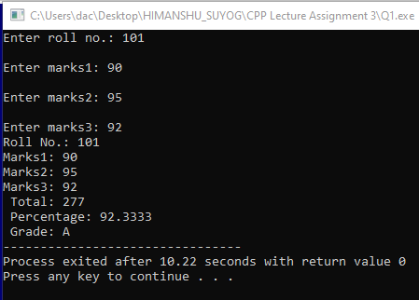
/*2. Create a class Person with data members as name, age, city. Write getters and setters for all the data members. Also add the display function. Create Default and Parameterized constructors. Create the object of this class in main method and invoke all the methods in that class. */
#include<iostream>
#include<string>
using namespace std;
class Person
{
private:
string name;
int age;
string city;

public:
Person()
{
cout << "----default constr.-----" << endl;
name = "Ram";
age = 2;
city = "anonymous";
}
Person(string name, int age, string city)
{
cout << "--------parameterised constr.---------" << endl;
this->name = name;
this->age = age;
this->city = city;
}
void setName(string name)
{
this->name = name;
}
void setCity(string city)
{
this->city = city;
}
void setAge(int age)
{
this->age = age;
}
string getName()
{
return name;
}
int getAge()
{
return age;
}
string getCity()
{
return city;
}
void display()
{
cout<<"Name: "<<name<<"Age: "<<age<<" City :"<<city<<endl;
}
};
int main()
{
Person p;
p.setName("Suyog");
p.setAge(25);
p.setCity("Bhilai");
p.getName();
p.getAge();
p.getCity();
p.display();
Person p2("Rohan", 30, "Bhopal");
p2.display();
Person p3;
cout<<"Name: "<<p3.getName()<<" Age: "<<p3.getAge()<<"City: "<<p3.getCity()<<endl;
return 0;
}
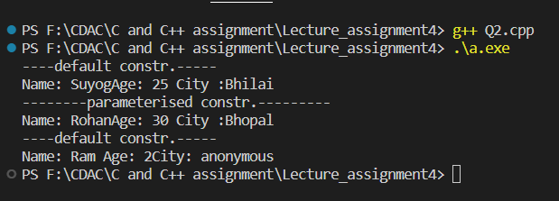

/*2. Create a class Date with data members as dd, mm, yy. Write getters and setters for all the data members. Also add the display function. Create Default and Parameterized constructors. Create the object of this class in main method and invoke all the methods in that class.*/
#include<iostream>
using namespace std;
class Date{
private:
int day, month, year;
public:
Date(){
cout<<"----default----"<<endl;
day = 1;
month = 11;
year = 1200;
}
Date(int day, int month, int year){
cout<<"------parameterised------"<<endl;
this->day = day;
this->month = month;
this->year = year;
}
void setDay(int day){
this->day = day;
}
void setMonth(int month){
this->month = month;
}
void setYear(int year){
this->year = year;
}
int getDay(){
return day;
}
int getMonth(){
return month;
}
int getYear(){
return year;
}
void display(){
cout<<"\nDate: "<<day<<"/"<<month<<"/"<<year<<endl;
}
};
int main(){
Date d1;
d1.display();
Date d2(12, 9, 2023);
d2.display();
Date d3;
d3.setDay(12);
d3.setMonth(9);
d3.setYear(2023);
d3.display();
Date d4;
int d, m, y;
cout<<"Day: ";
cin>>d;
d4.setDay(d);
cout<<"\nMonth: ";
cin>>m;
d4.setMonth(m);
cout<<"\nYear: ";
cin>>y;
d4.setYear(y);
cout<<"\nDate: "<<d4.getDay()<<"/"<<d4.getMonth()<<"/"<<d4.getYear()<<endl;
return 0;
}
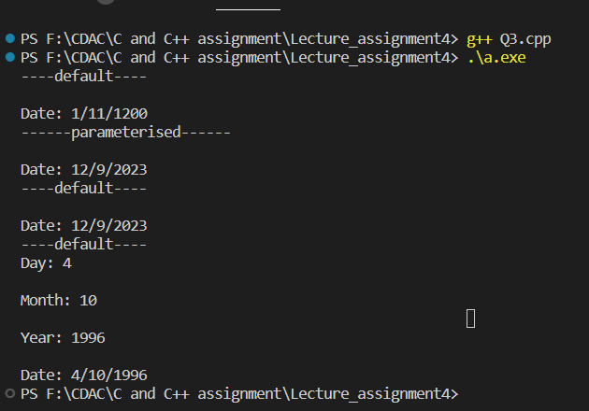

/*3. Create a class Book with data members as bname,id,author,price. Write getters and setters for all the data members. Also add the display function. Create Default and Parameterized constructors. Create the object of this class in main method and invoke all the methods in that class.*/
#include<iostream>
#include<string>
using namespace std;
class Book{
private:
string bname, author;
int id, price;
public:
Book(){
cout<<"-----default-----"<<endl;
bname = "Thermodynamics";
author = "Naveen";
id = 404;
price = 500;
}
Book(string bname, string author, int id, int price){
cout<<"------parameterised-------"<<endl;
this->bname = bname;
this->author = author;
this->id = id;
this->price = price;
}
void setId(int id){
this->id = id;
}
void setBname(string bname){
this->bname = bname;
}
void setAuthor(string author){
this->author = author;
}
void setPrice(int price){
this->price = price;
}
string getBname(){
return bname;
}
int getId(){
return id;
}
string getAuthor(){
return author;
}
int getPrice(){
return price;
}
void display(){
cout<<"\nBook: "<<bname<<" author: "<<author<<" id: "<<id<<" price: "<<price<<endl;
}
};
int main(){
Book b1;
b1.display();
Book b2("Let_us_C", "Yashwant_Kanitkar", 101, 435);
b2.display();
Book b3;
b3.setBname("Computer_Fundamentals");
b3.setAuthor("Pradeep_Sinha");
b3.setId(202);
b3.setPrice(935);
b3.display();
string bname, author;
int id, price;
cout<<"\nEnter name, author, id and price of book"<<endl;
cin >> bname >> author >> id >> price;
Book b4(bname, author, id, price);
b4.display();
return 0;
}
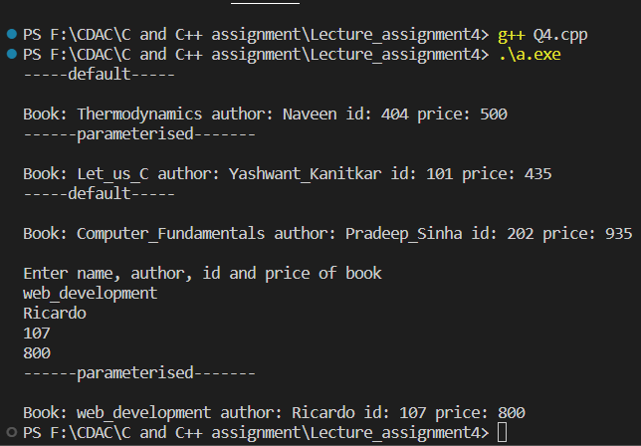

/*4. Create a class Point with data members as x,y. Create Default and Parameterized constructors. Write getters and setters for all the data members. Also add the display function. Create the object of this class in main method and invoke all the methods in that class.*/
#include<iostream>
#include<string>
using namespace std;
class Point{
private:
int x, y;
public:
Point(){
cout<<"-----default-----"<<endl;
x = 1;
y = 1;
}
Point(int x, int y){
cout<<"------parameterised-------"<<endl;
this->x = x;
this->y = y;
}
void setX(int x){
this->x = x;
}
void setY(int y){
this->y = y;
}
int getX(){
return x;
}
int getY(){
return y;
}
void display(){
cout<<"\nPoint is: \n"<<"X: "<<x<<" Y:"<<y<<endl;
}
};
int main(){
Point p1;
p1.display();
Point p2(50, 20);
p2.display();
Point p3;
p3.setX(80);
p3.setY(10);
p3.display();
int x, y;
cout<<"\nEnter point x and y: "<<endl;
cin >> x >> y;
Point p4(x, y);
p4.display();
return 0;
}

/*5. Create a class ComplexNumber with data members real, imaginary. Create Default and Parameterized constructors. Write getters and setters for all the data members. Also add the display function. Create the object of this class in main method and invoke all the methods in that class.*/
#include<iostream>
#include<string>
using namespace std;
class ComplexNumber{
private:
int real, imaginary;
public:
ComplexNumber(){
cout<<"-----default-----"<<endl;
real = 1;
imaginary = 1;
}
ComplexNumber(int real, int imaginary){
cout<<"------parameterised-------"<<endl;
this->real = real;
this->imaginary = imaginary;
}
void setReal(int real){
this->real = real;
}
void setImaginary(int imaginary){
this->imaginary = imaginary;
}
int getReal(){
return real;
}
int getImaginary(){
return imaginary;
}
void display(){
cout<<"Complex number is: "<<real<<" + "<<imaginary<<"i"<<endl;
}
};
int main(){
ComplexNumber c1;
c1.display();
ComplexNumber c2(7, 3);
c2.display();
ComplexNumber c3;
c3.setReal(8);
c3.setImaginary(1);
c3.display();
int real, imaginary;
cout<<"\nEnter real and imaginary value: "<<endl;
cin >> real >> imaginary;
ComplexNumber c4(real, imaginary);
c4.display();
return 0;
}
